*Федеральное государственное бюджетное образовательное учреждение* *высшего образования*

|  |  |
| --- | --- |
|  | ***«Московский государственный технический университет  имени Н.Э. Баумана»***  ***(национальный исследовательский университет)***  ***(МГТУ им. Н.Э. Баумана)*** |

**Презентация на тему *«Cloud computing»***

**Дисциплина: Иностранный язык**

Студент гр. ИУ6-22Б **А. П. Плютто**

Преподаватель **М. В. Юдина**

Москва, 2023

**Plan:**

1. Introduction
2. What is Cloud Computing?
3. Advantages of Cloud Computing
4. Disadvantages of Cloud Computing
5. Best Practices for Implementing Cloud Solutions
6. Conclusion

**Slides:**

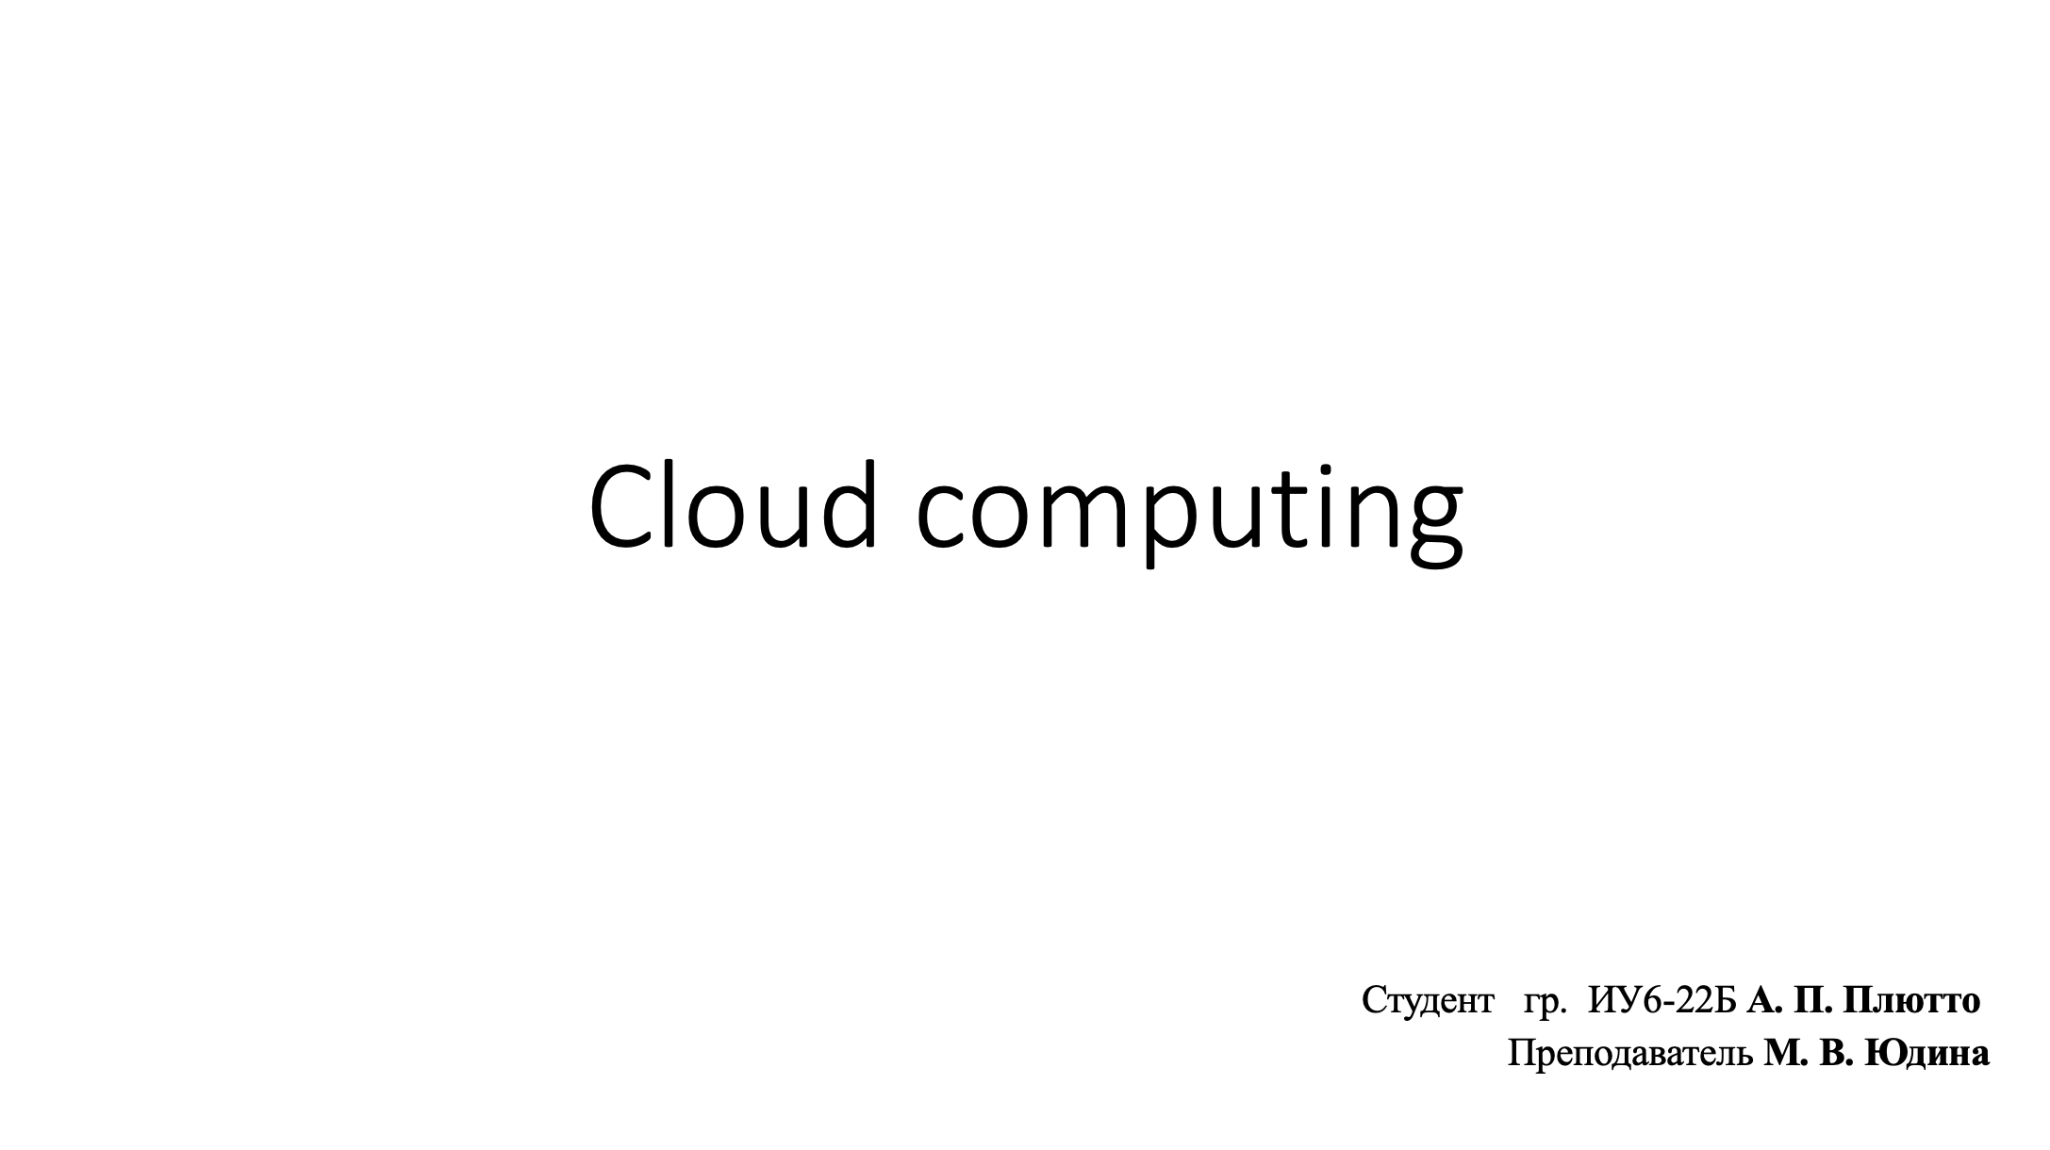

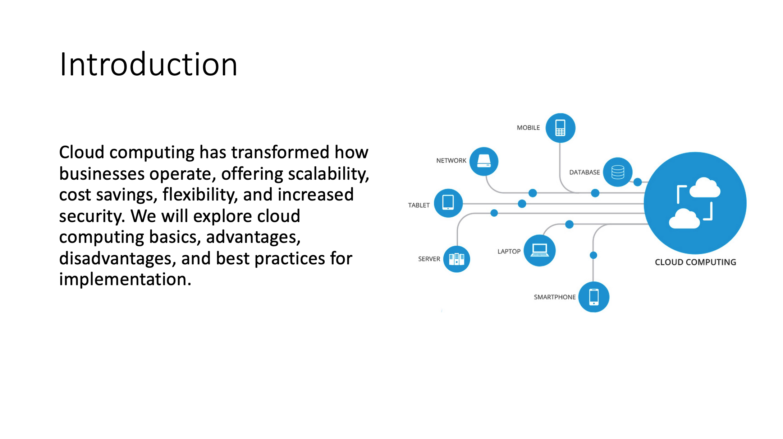

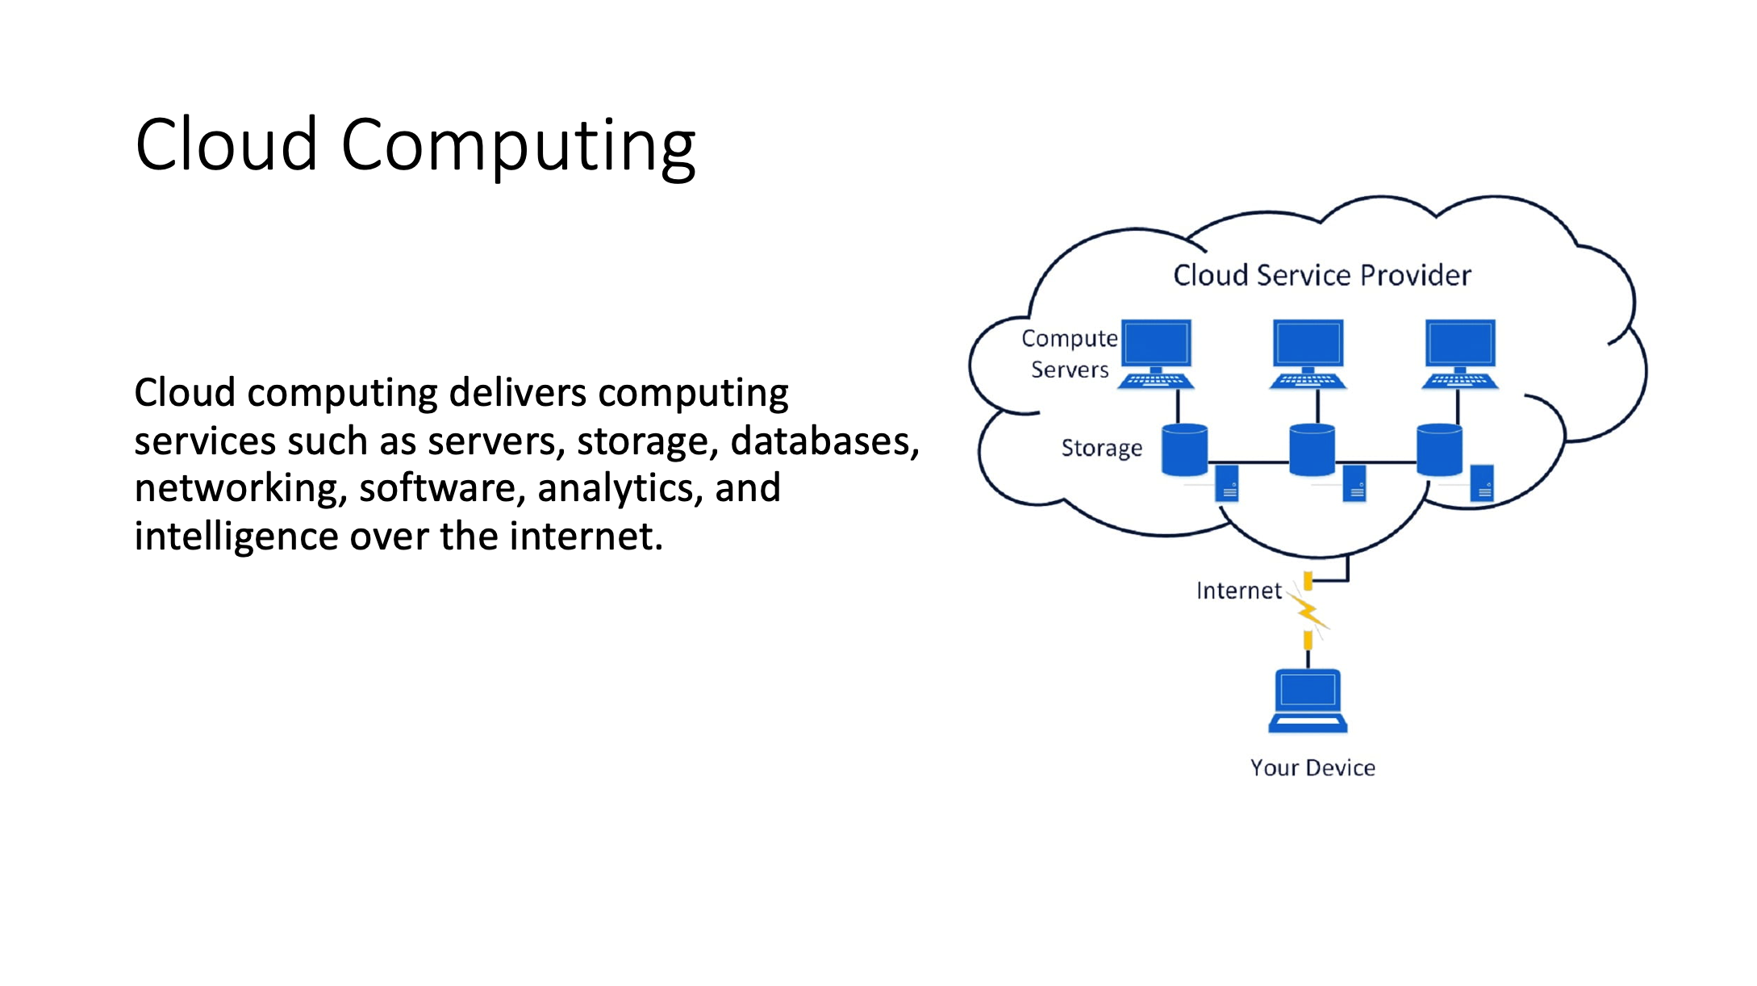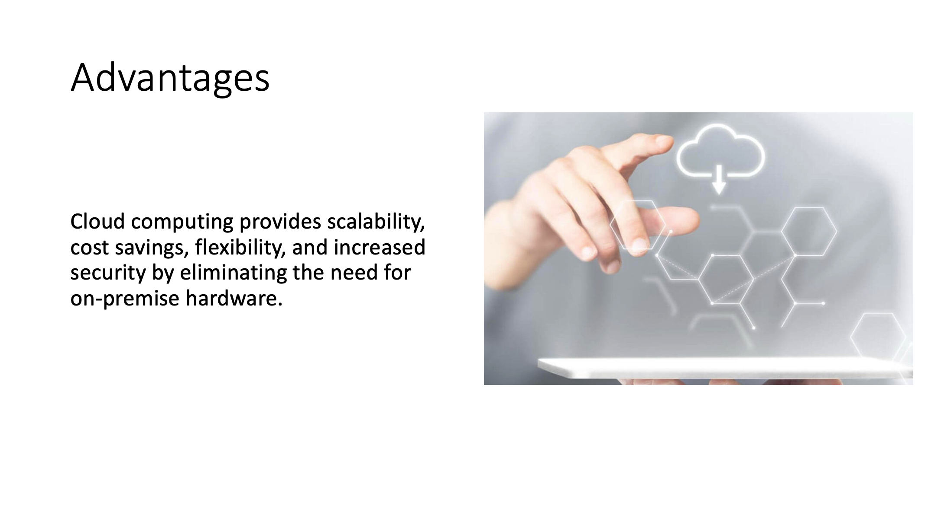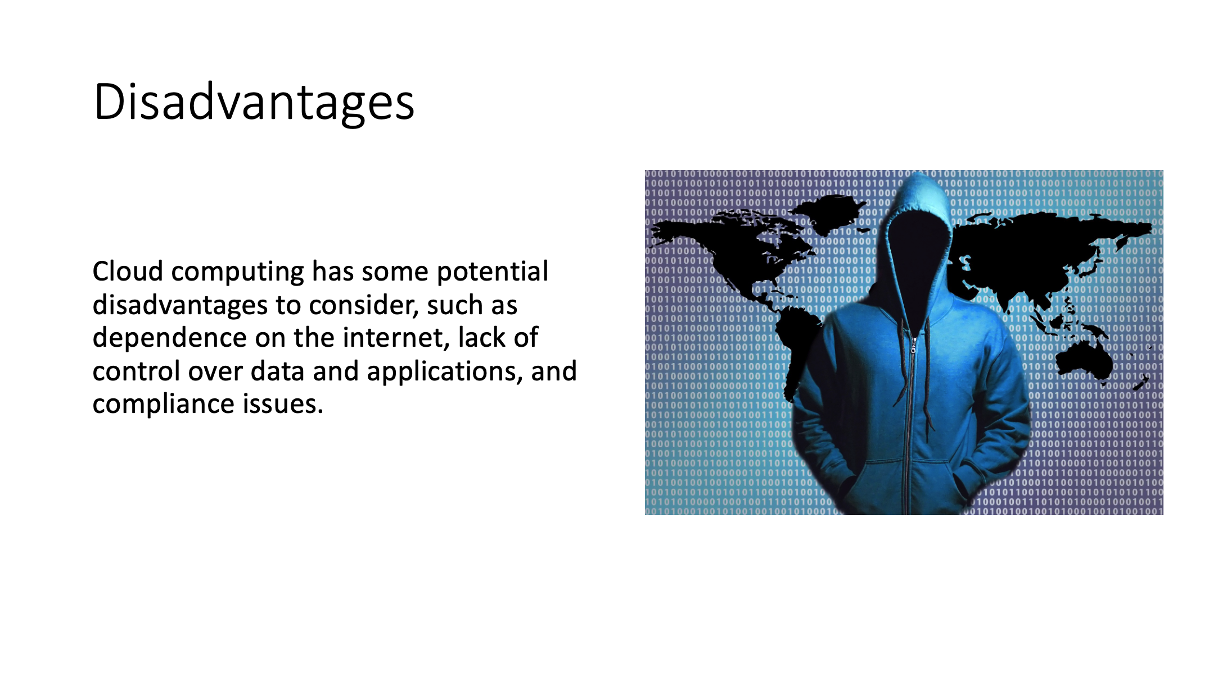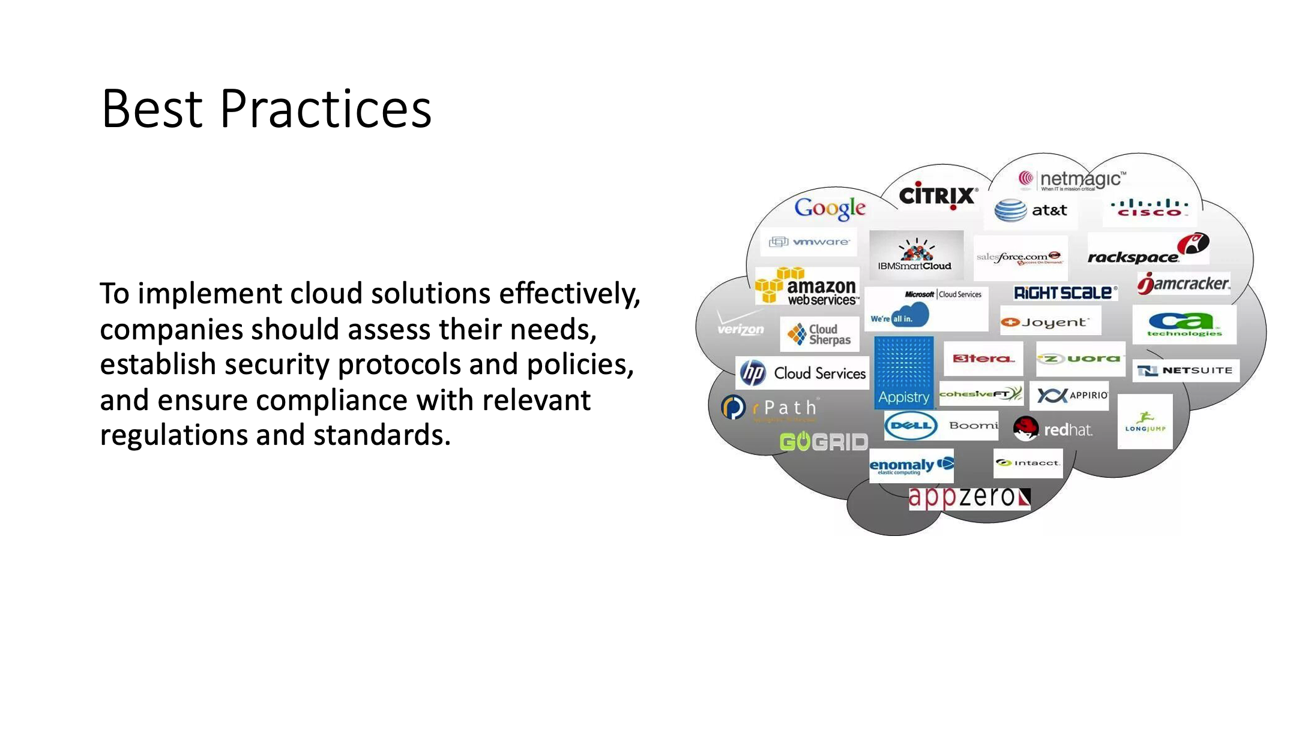

**Text:**

Introduction:

Cloud computing is a technology that has transformed the way businesses operate in the modern world. It has allowed companies to scale their operations and increase their efficiency, while reducing costs and eliminating the need for on-premise hardware. In this presentation, we will explore the basics of cloud computing, its advantages and disadvantages, and best practices for implementing cloud solutions.

What is Cloud Computing?

Cloud computing is the delivery of computing services, including servers, storage, databases, networking, software, analytics, and intelligence, over the internet. Cloud services are provided by third-party providers, who own and operate the infrastructure, while clients can access the services on a pay-as-you-go basis.

Advantages of Cloud Computing:

Cloud computing offers several advantages over traditional on-premise computing solutions. Some of the key advantages include:

1. Scalability: Cloud solutions allow companies to scale up or down their resources as needed, without the need for additional hardware.
2. Cost savings: Cloud solutions eliminate the need for on-premise hardware, resulting in significant cost savings for companies.
3. Flexibility: Cloud solutions allow companies to access their data and applications from anywhere with an internet connection, making it easier to work remotely.
4. Increased security: Cloud providers typically have more advanced security measures in place than on-premise solutions, which can help to protect against data breaches and other security threats.

Disadvantages of Cloud Computing:

While there are many benefits to cloud computing, there are also some potential disadvantages to consider. Some of the key disadvantages include:

1. Dependence on the internet: Cloud solutions require a reliable internet connection, which can be a problem in areas with poor connectivity.
2. Lack of control: Cloud solutions are managed by third-party providers, which means that companies may have less control over their data and applications.
3. Compliance issues: Companies may need to comply with various regulations and standards when storing data in the cloud, which can be a challenge.

Best Practices for Implementing Cloud Solutions:

To ensure that cloud solutions are implemented effectively, there are several best practices that companies should follow. Some of these include:

1. Assessing needs: Companies should carefully assess their needs and choose a cloud provider that can meet their specific requirements.
2. Establishing security protocols: Companies should establish clear security protocols and policies to protect their data and applications.
3. Ensuring compliance: Companies should ensure that they are complying with all relevant regulations and standards when storing data in the cloud.

Group: ИУ6-22Б

Student: **А. П. Плютто**

Supervisor: **М. В. Юдина**

**Apple II**

Apple II was a personal computer that was designed, developed, and marketed by Apple Computer Inc. in the late 1970s and early 1980s. The Apple II was released in 1977, and it quickly became one of the most successful personal computers of its time. It was the first mass-produced microcomputer, and it helped to popularize personal computing in homes and businesses across the world.

The Apple II was an 8-bit computer that was based on the MOS Technology 6502 microprocessor. It had a clock speed of 1 MHz and came with 4 KB of RAM, which could be expanded to 48 KB. The computer had a built-in keyboard, a monochrome monitor, and a cassette tape drive for storing data. It also had expansion slots that allowed users to add peripherals such as floppy disk drives, printers, and modems.

One of the key features of the Apple II was its open architecture. The computer was designed to be easily expandable, and it had a wide range of expansion options that allowed users to customize the system to their specific needs. This made the Apple II popular with hobbyists and tinkerers who enjoyed experimenting with new hardware and software.

The Apple II was also notable for its software ecosystem. Apple Computer Inc. provided a wide range of software for the computer, including the Apple DOS operating system, which was later replaced by ProDOS. Additionally, a thriving software industry grew up around the Apple II, with third-party developers creating games, productivity software, and other applications.

One of the most successful software titles for the Apple II was VisiCalc, a spreadsheet program that was released in 1979. VisiCalc helped to establish the Apple II as a serious business machine, and it was instrumental in popularizing the use of spreadsheets in businesses across the world.

The success of the Apple II helped to establish Apple Computer Inc. as a major player in the computer industry. The company went public in 1980, and the Apple II remained a popular product throughout the 1980s, even as newer computers were released. Apple Computer Inc. eventually discontinued the Apple II in 1993, but the computer had a lasting impact on the industry and on popular culture.

In conclusion, the Apple II was a groundbreaking computer that helped to popularize personal computing and establish Apple Computer Inc. as a major player in the industry. Its open architecture, expandability, and software ecosystem set the standard for future personal computers, and its legacy continues to be felt today. The Apple II was truly a game-changer, and it will always hold a special place in the history of computing.